

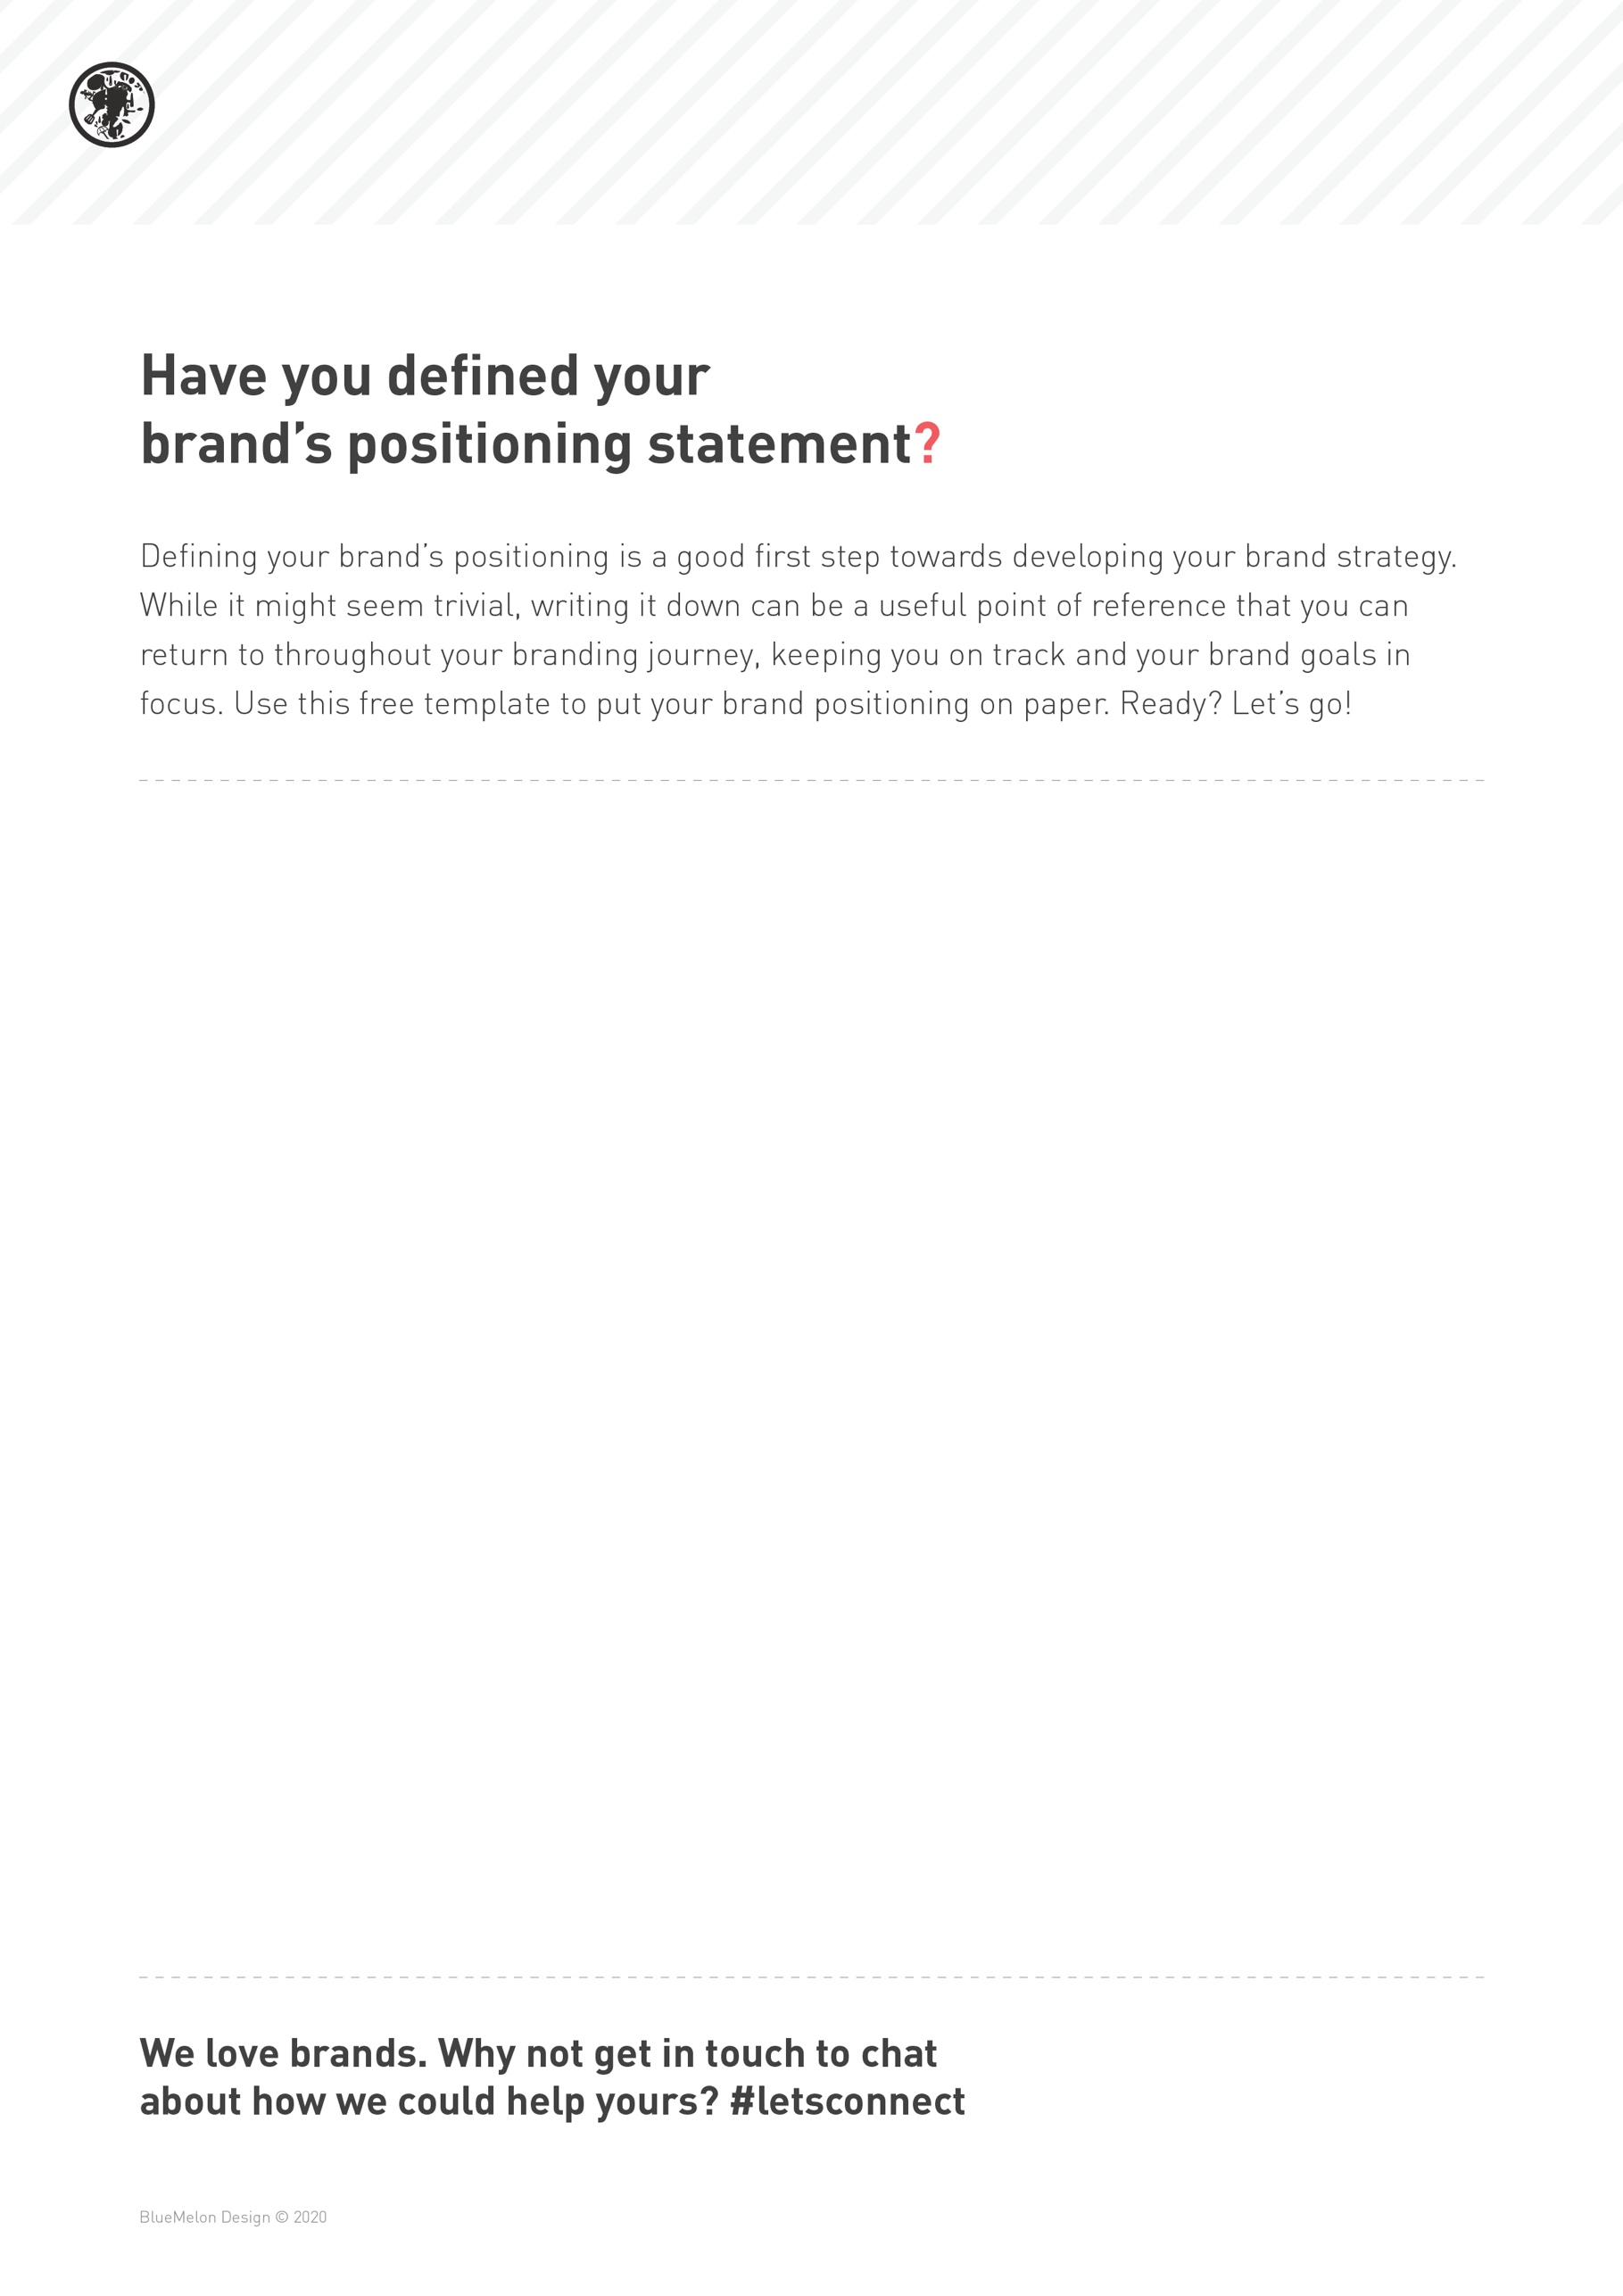

Our brand [enter brand name here] is for [enter target audience] who [enter audience need] so that they can [enter audience goal].

We do this by [enter how your brand provides value].

We do it differently, by [enter your brands point of difference].

We are here to [enter your brand philosophy, mission statement, motto or tagline].

**Example:**

*Our brand, Lunar Body, is for health-aware people of all ages who need activewear that works out with them, not against them, so that they can focus on their health and fitness goals instead of uncomfortable clothing.*

*We do this by embodying the anatomy of all kinds of people and all kinds of movement.*

*We do it differently, because we design for bodies in motion, not for mannequins.*

*We are here to work out with you.*